Assignment on

Internet Technologies

Corse: BSc (Hons) CS & DF

(Sem_2)

**NAME: AMAN YADAV**

**STUDENT ID: 10722**

**Week 9**

**Task 1:**

Reproduce the following table using CSS positioning (relative or absolute) instead of <table>.

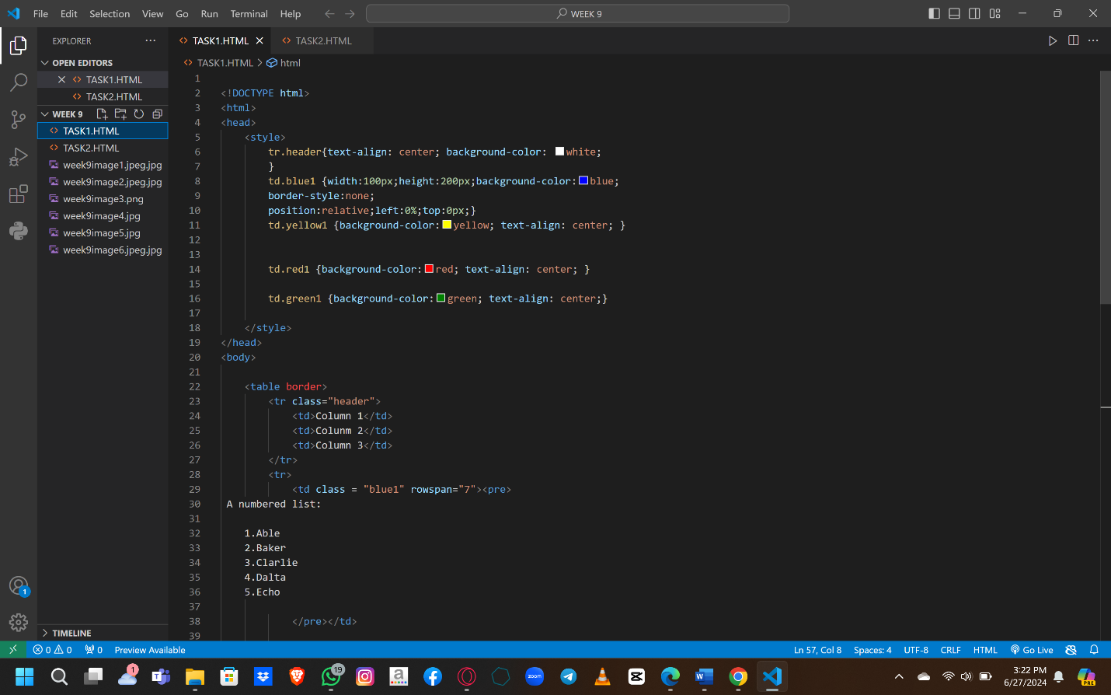

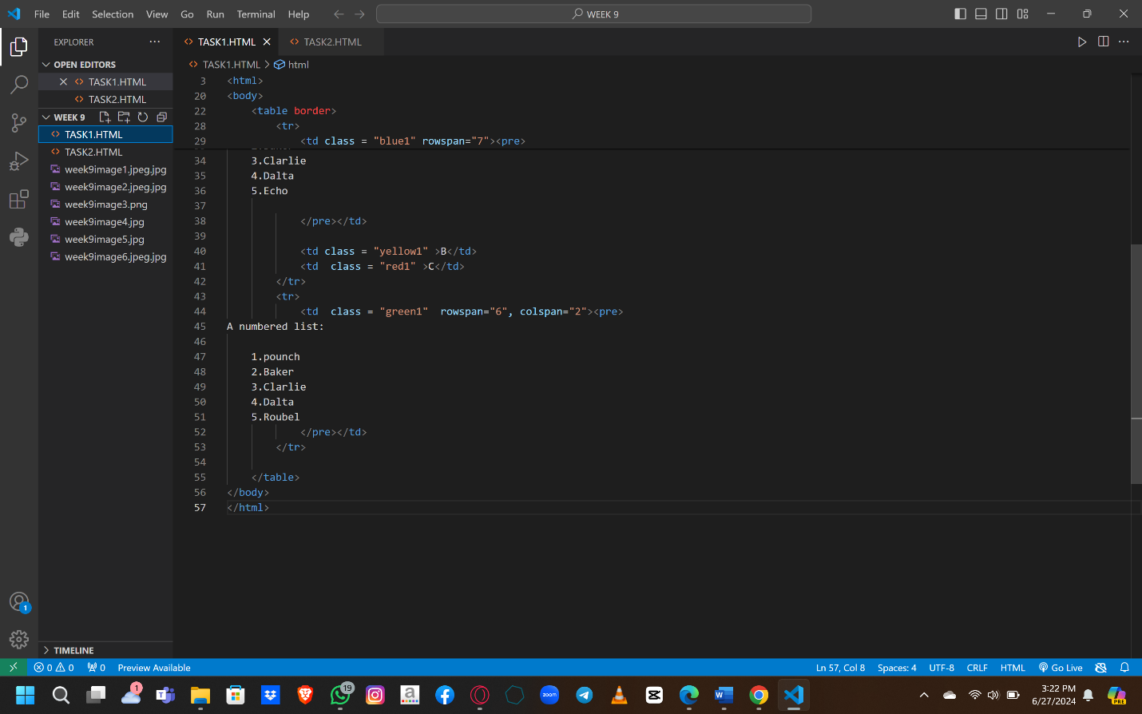

Output:

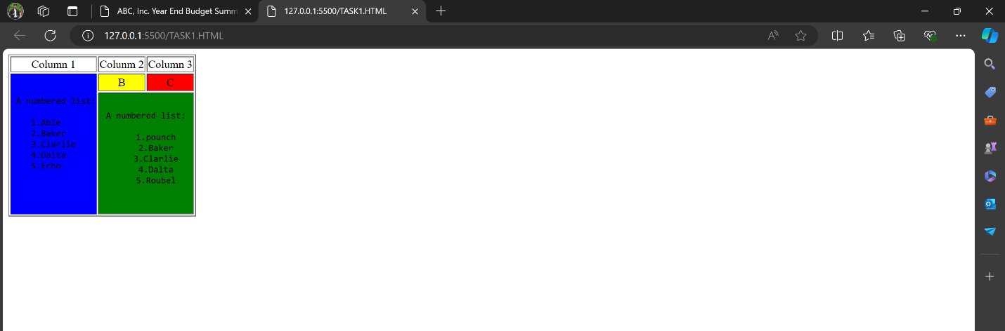

Task 2:

Question no 2:

Write the appropriate CSS to change the presentation of the webpage to that shown in figure below. The new page

layout includes a header section, two columns (one for navigation menu and one for the main content) and a footer

section.

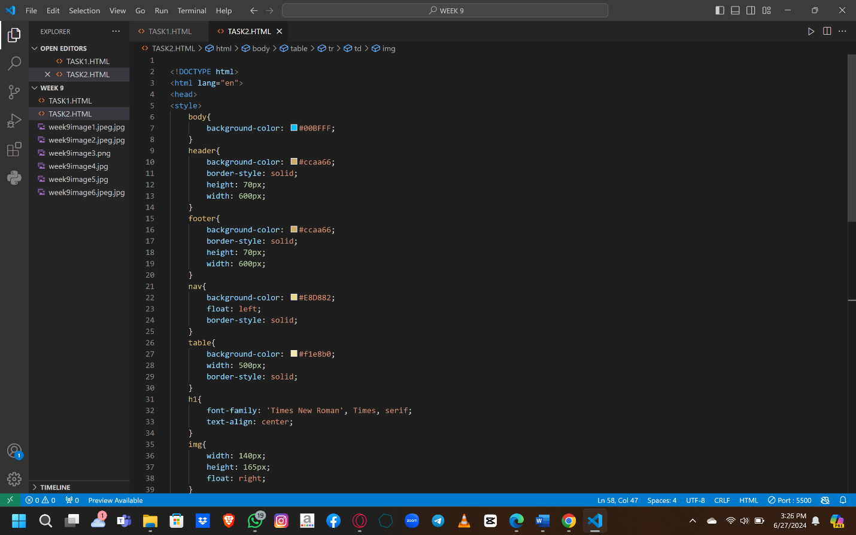

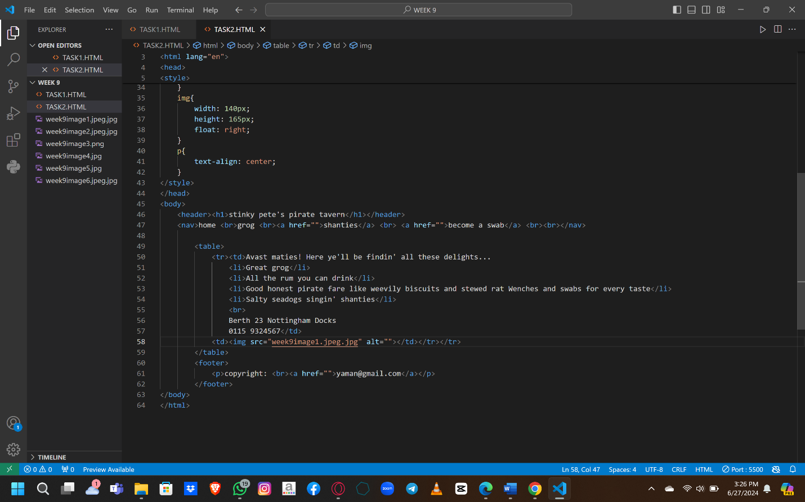

Output:

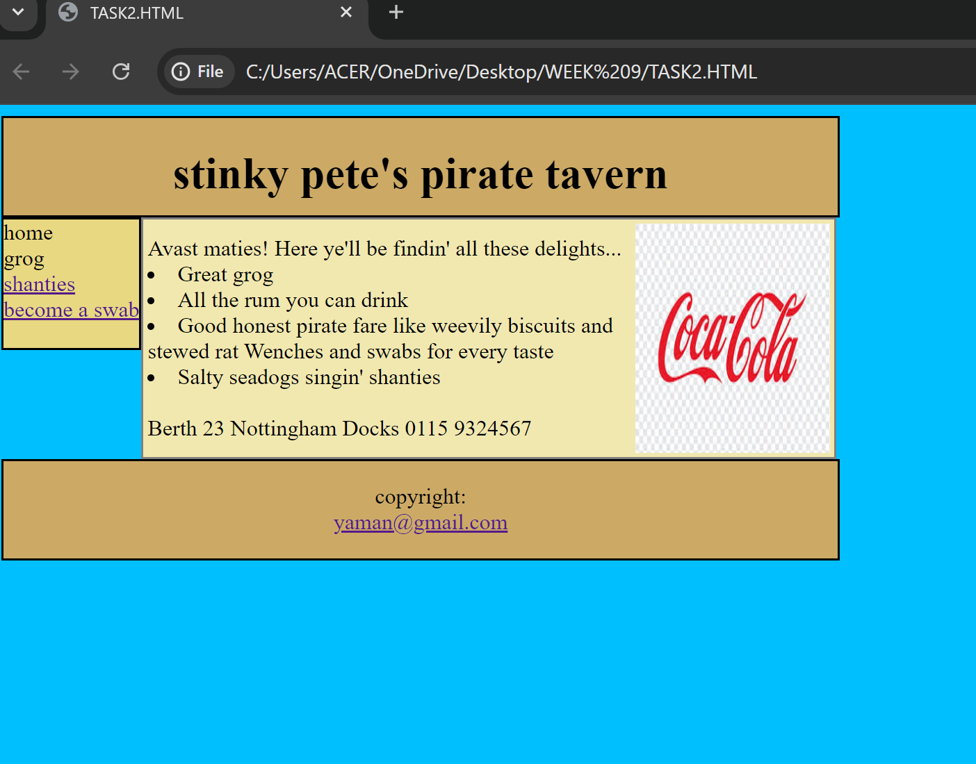

Task 3:

Question 3:

Create the following layout by HTML AND CSS

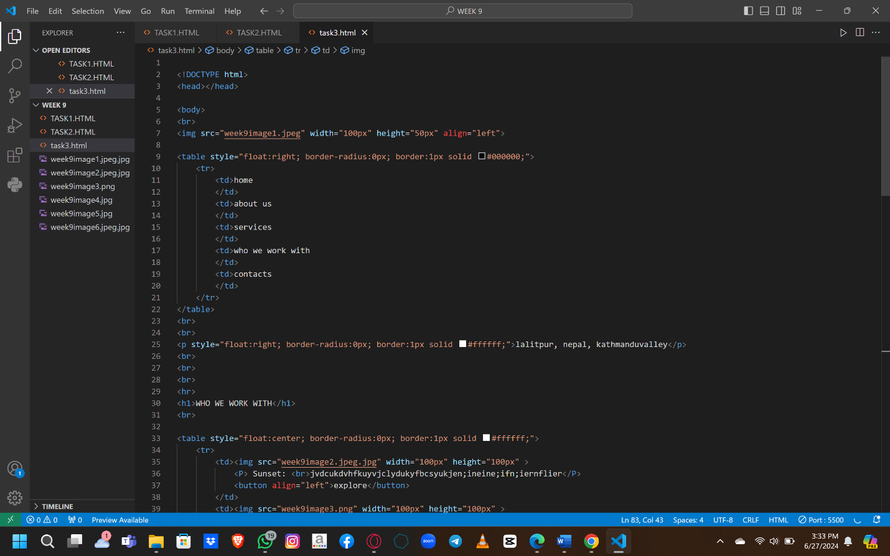

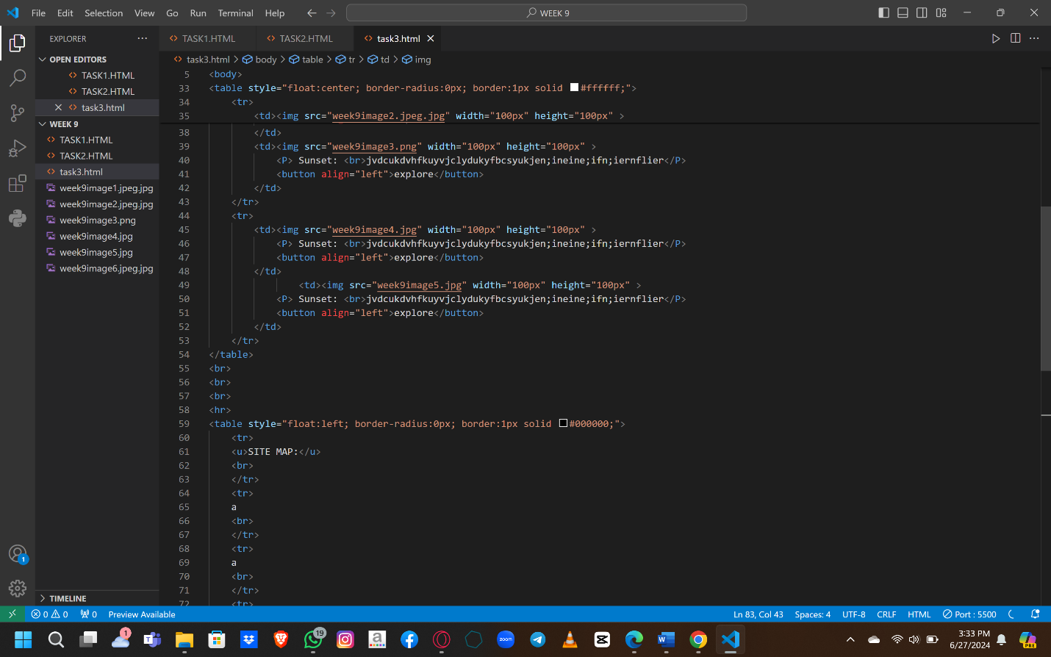

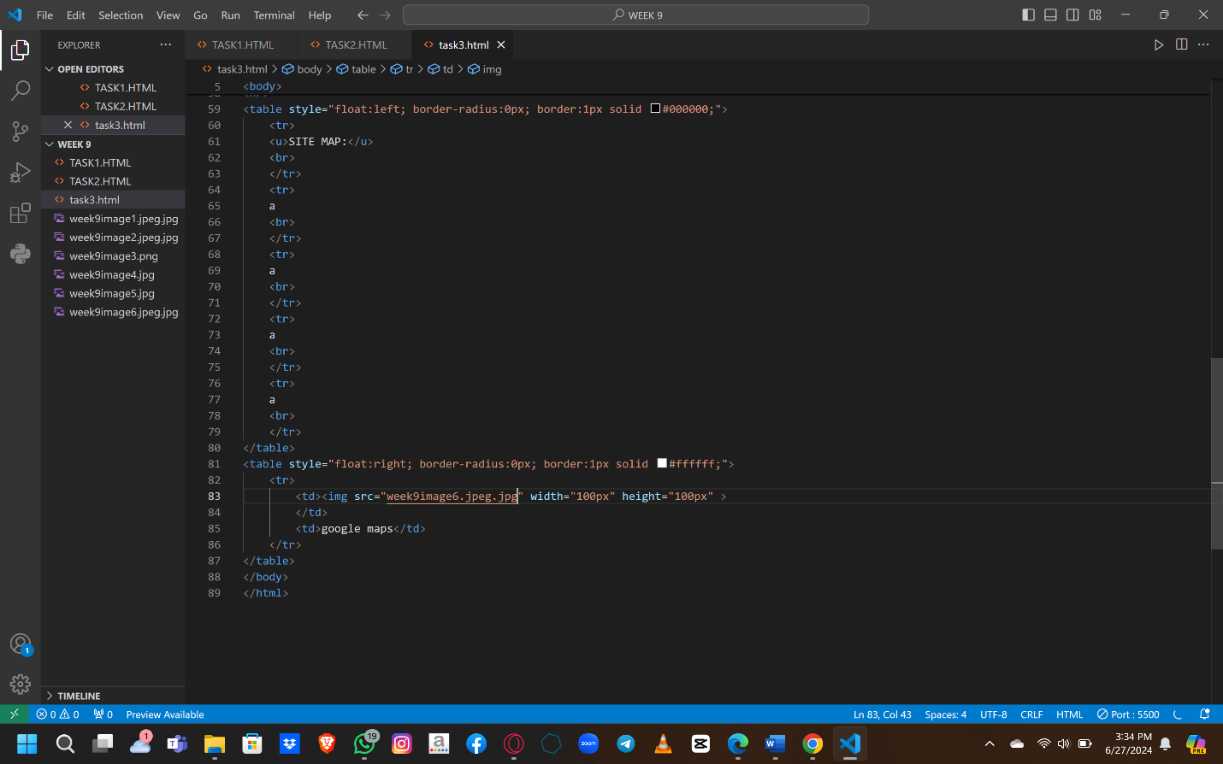

Output:

